Test6
The sphere has a mass of 6 kg and is supported as shown. Draw a free-body diagram of the sphere, cord CE, and the knot at C.  Solution:  Sphere: | 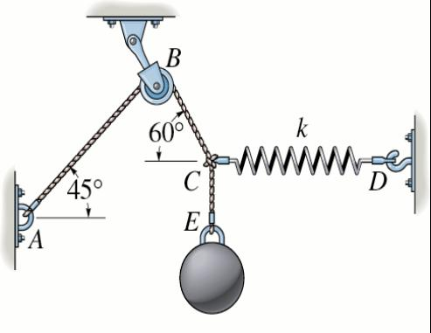
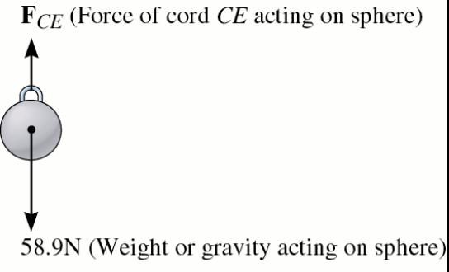 |  | There are two forces acting on the sphere. These are its weight and the force of cord CE.  The weight is:  W = 6 kg (9.81 m/s2)=58.9 N.  F_{CE}
FBD of sphere
58.9 N
Cord EC:
There are two forces acting on the cord. These are the force of the sphere, and the force of the knot. A cord is a tension only member. Newton’s third law applies.
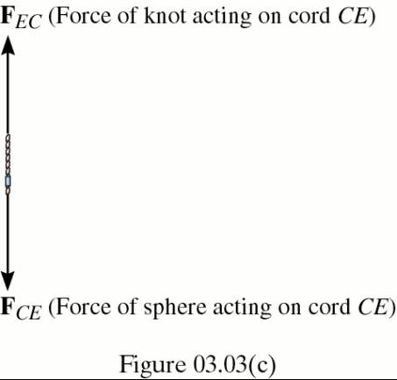 FBD of Cord CE:
C
E
F_{EC}
F_{CE}
Knot at C:

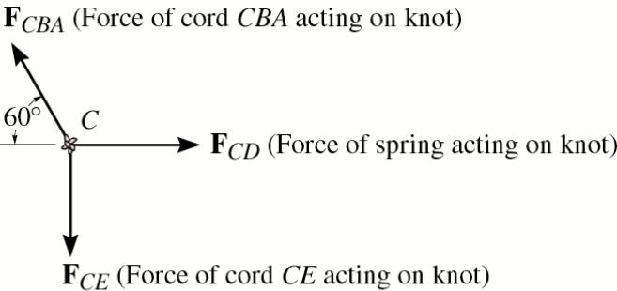

There are three forces acting on the knot at C. These are the force of the cord CBA, and the force of the cord CE, and the force of the spring CD.
60
F_{CD}
F_{CE}
F_{CBA}
C

FBD of Cord EC:

