Differentiation, Integration and Centroids

Differentiation (common derivatives):
d/dx( c )= 0
The derivative of a constant is zero.
Example: d/dx 7 = 0
d/dx( c × x )= c
The rate of change of a linear function is its slope.
Example: d/dx 3 × x = 3
d/dx (x^{n}) = n × x^{(n-1)}
Example: d(x⁴)/dx = 4 × x ³
d/dx (log x) = 1/x
The derivative of the log of x is its inverse.
Example: d(log (x + 1))/dx = 1 / (x + 1)
d/dx (e^{ax}) = a e^{ax}
Example: d (e^{3x}) /dx= 3 e^{3x}
d/dx (sin cx) = c cos x
Example: d(sin3x) /dx = 3cos x
d/dx (cos x) = -sin x
Example: d (cos ) /dx= - sin

Integral of a function: The integral of a function f(x) over an interval from x₁ to x₂ yield the area under the curve in this interval
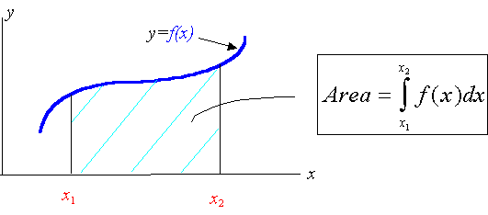
Note: The integral represents the as .
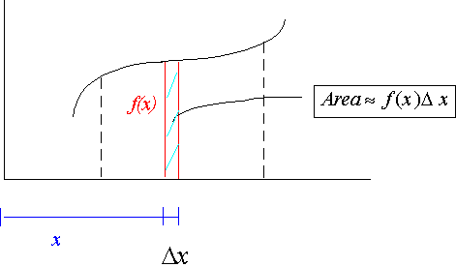
Some indefinite integrals to remember:
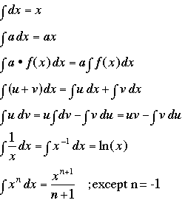
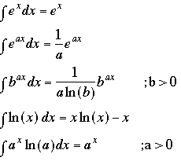
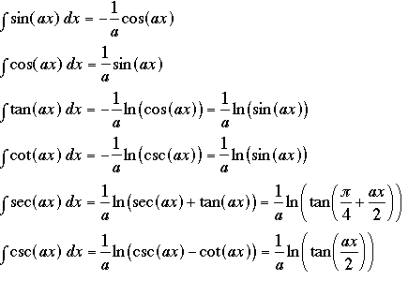

Note: Remember to add a constant of integration if you are not specifying limits. You evaluate the constant of integration by forcing the integral to pass through a known point.
Note: For definite integrals subtract the value of the integral at the lower limit from its value at the upper limit. For example, if you have the indefinite integral.

Note: The following notation is common
Integration by parts:
Centroid of an area: The centroid of an area is the area weighted average location of the given area.
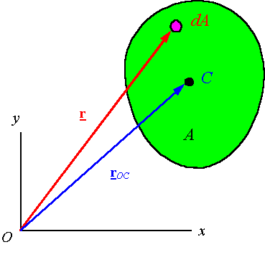

Centroids of common shapes:

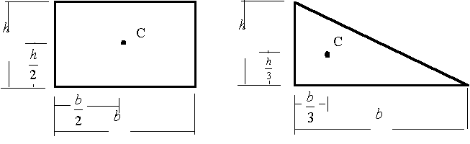
Some other centroids of common shapes of areas and lines are as follow:

Shapes | Images |  |  | Area
Triangular Area | 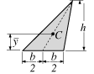
Quarter–circular area | 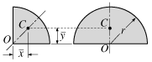
Semicircular area |  | 0
Semiparabolic area | 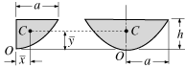
Parabolic area |  | 0
Parabolic spandrel | 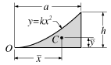
Circular Sector | 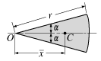 |  | 0
Quarter-circular arc | 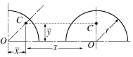
Semicircular arc |  | 0
Arc of circle | 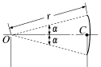 |  | 0

