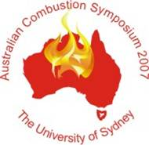 | 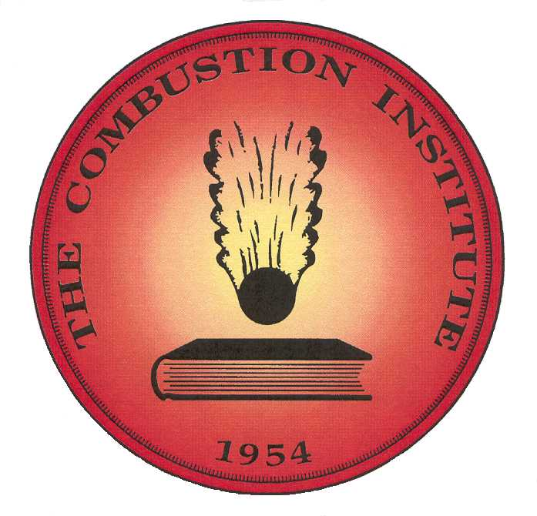

Australian Combustion Symposium 2007 Registration Form

Contact details
Name | :
Address | :
Email | :
Phone | :
Fax | :
Name (for badge) | :
Institution/Company | :

Conference details
Conference registration includes:
BBQ welcome dinner and Combustion Institute BGM, Sunday 9th December
ACS 2007 presentations, Monday and Tuesday 10th and 11th December
Bound conference proceedings
CD of conference proceedings
Lunch, morning and afternoon tea, Monday and Tuesday 10th and 11th December
Banquet Dinner, Monday 10th December

Catering Details
Will you attend the welcome dinner? | : Yes/No
Do you have any special dietary requirements? | : Please Describe

Registration Details
Please remove () and fill in number and total as appropriate. All prices in AUD.
Before 16th November 2007
Earlybird Registration | $550 | 
Earlybird Student | $300 | 
After 16th November
Registration | $650 | 
Student Registration | $350 | 
Extra Banquet Tickets | $80 | (number)
Total | :

Payment Details

I would like to (delete as required):

 Pay by cheque made out to “The University of Sydney”
Please put your name on the back of the cheque and post to
Dr K. Sendt
School of Chemical and Biomolecular Engineering J01
University of Sydney 2006

 Pay by credit card
Visa Mastercard Other

Cardholder’s name | :
Card number | :
Expiry Date | :
Security Code  (3 digits on reverse) | :
Cardholder’s signature

All payment methods:
Please fax the completed form to (02) 9351 3471

