Template for Extended Abstracts for 8ANCW

First Author^{1*}, Second Author¹ and Third Author²

¹Affilation of the indicated author(s)

²Affilation of the indicated author(s)

*Email address of the author for correspondence

1. INTRODUCTION
Extended abstracts to be submitted to the 8ANCW are required to be formatted in accordance with this template. All extended abstracts should include an INTRODUCTION, providing a statement of the problem.
The INTRODUCTION may also contain a brief summary of relevant literature with references to published works [1-3]. All cited references should be listed at the end of the extended abstract in the order of occurrence and are formatted as shown by the examples in this template. Among the listed references, [1] is a journal article, [2] is a thesis, [3] is a paper from a conference proceeding, [4] is a chapter from a book, and [5] is a book. Journal titles, conference names and book names should be italicised and should not be abbreviated.
2. FORMATTING REQUIREMENTS
The title is in a 14-point boldface Arial font. It should be in lower case with the first letter of major words in upper case. The names of each author should be in a 10-point boldface Arial font. The authors’ affiliations are also in 10-point Arial font, and should include the institution’s name, city and country.
The main text of the extended abstract is in a Times New Roman font with a font size of 12 points. Smaller font sizes (10 or 11) may be used for the list of references. All paragraphs are text justified. The first line of each paragraph is indented by 0.5cm. There is no blank line between paragraphs.
The main body of the extended abstract may contain one or more Sections with properly numbered headings such as ‘2. APPROACH’ and ‘3. RESULTS’. Avoid having sub-sections. Section headings are in boldface 12-point CAPITAL Times New Roman font.
Extended abstracts including references should not exceed two full A4 pages.
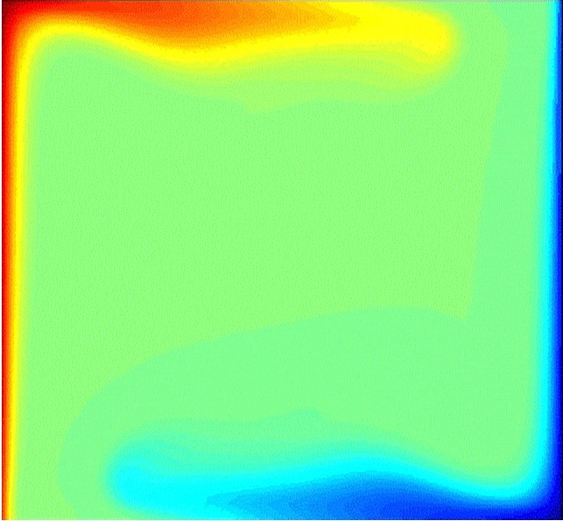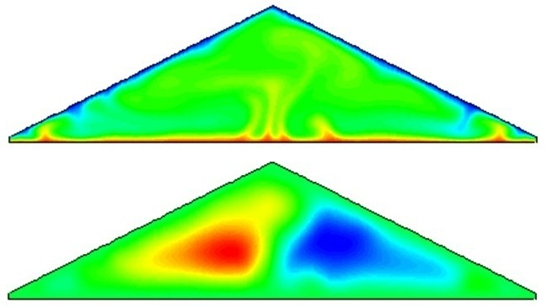
(a) (b)
Figure 1. This figure and its caption are centred. The width of the caption is adjusted according to the size of the figure. The caption is in a Times New Roman font with a font size of 11 points.
3. FIGURES AND TABLES
Authors are encouraged to include one or more figures or tables to illustrate major results. Figures and tables are centred in the column of text, and the width of the figures and tables should not exceed the width of the text column. Text in tables and figures should be no smaller than font size 10. Figures and tables must be sequentially numbered and labelled. Figure and table captions are in an 11-point Times New Roman font. Colours may be used in both figures and tables.
4. CONCLUSIONS
The conclusions section should contain a brief summary of major findings.
REFERENCES
[1] Author1 A. & Author2 B. (2010) This is the title of the journal article, Name of the Journal, 180, 350-379.
[2] Author C. (1999) This is the title of the thesis, Ph.D. Thesis, School of XXXX, The University of XXXX, City, Country.
[3] Author1 A., Author2 B. & Author3 C. (2012) This is the title of the conference paper. In, Editor D., Title of the Conference Proceedings, Organiser, City, Country, Dates, Paper 123 (or Page 10-15).
[4] Author1 A., Author2 B. & Author3 C. (2012) Chapter Title in Book Title, editors A. Editor1 and B. Editor2, Publisher, 27-42.
[5] Author A. (1980) The Title of the Book, 3rd Edition, Publisher.

